**DEBIT DAWN**

A Project Report

*Submitted by:*

**Devjeet Paltasingh (1841017175)**

**Rajshiona Samal (1841017052)**

**Ashutosh Maharana (1741017204)**

In partial fulfilment for the award of the degree of

**BACHELORS OF TECHNOLOGY**

**IN**  
**COMPUTER SCIENCE AND INFORMATION TECHNOLOGY**



**DEPARTMENT OF COMPUTER SCIENCE AND INFORMATION TECHNOLOGY**

**Faculty of Engineering and Technology, Institute of Technical Education and Research**

**SIKSHA ‘O’ ANUSANDHAN (DEEMED TO BE) UNIVERSITY**

**Bhubaneswar, Odisha, India (October 2022)**

# CERTIFICATE

# This is to certify that the project report titled “DEBIT DAWN-THE MIDDLE MAN YOU NEED” being submitted by Devjeet Paltasingh, Rajshiona Samal, and Ashutosh Maharana of LP-NP 2022, to the Institute of Technical Education and Research, Siksha ‘O’ Anusandhan (Deemed to be) University, Bhubaneswar for the partial fulfilment for the degree of Bachelor of Technology in Computer Science and Information Technology is a record of original confide work carried out by them under my/our supervision and guidance. The project work, in my/our opinion, has reached the requisite standard fulfilling the requirements for the degree of Bachelor of Technology.

# The results contained in this thesis have not been submitted in part or full to any other University or Institute for the award of any degree or diploma.

**Dr. Sangram Panigrahi**

Department of Computer Science and Information Technology

Faculty of Engineering and Technology.

Institute of Technical Education and Research.

Siksha ‘O’ Anusandhan (Deemed to be) University

# ACKNOWLEDGEMENT

# We would like to express sincere gratitude towards our team members for actively taking part in the project completion process. We would like to thank our supervisor, Dr. Sangram Panigrahi Sir for his guidance and for his enthusiasm, patience, feedback, information, and ideas that helped us extremely well in presenting the project in a brilliant manner. Without his support, the project would have been impossible to complete. Imagining a better supervisor than him is next to impossible.

# We are highly indebted to our university Institute of Technical Education and Research (I.T.E.R.) for guidance and constant supervision regarding the support of the project. We would also like to thank our parents and fellow team members for motivating us to complete the project.

# We express our sincere gratitude to the Computer Science and Technology Prof. (Dr.) Ajit Kumar Nayak (HOD) who allowed us to use the facilities of the institute.

# We are also thankful to all those who have helped us in this endeavour either directly or indirectly, especially all our teachers. At last, we would like to express a big thanks to all our friends and all known and unknown people who helped us directly or indirectly.

# DECLARATION

# We declare that this written submission represents our ideas in our own words and where other’s ideas or words have been included, we have adequately cited and referenced the original sources. We also declare that we have adhered to all principles of academic honesty and integrity and have not misrepresented or fabricated or falsified any idea/fact/source in our submission. We understand that any violation of the above will cause for disciplinary action by the University and can also evoke penal action from the sources which have not been properly cited or from whom proper permission has not been taken when needed.

**Signature of Students with Registration Numbers**

Devjeet Paltasingh- 1841017175

Rajshiona Samal – 1841017052

Ashutosh Maharana– 1741017204

Date: 26 October,2022

# REPORT APPROVAL

# This project report entitled “DEBIT DAWN-THE MIDDLE MAN YOU NEED” by Devjeet Paltasingh, Rajshiona Samal and Ashutosh Maharana is approved for the degree of Bachelor of Technology in Computer Science and Information Technology.

________________________________

**Examiners**

# ABSTRACT

# Debit Dawn-The middleman you need, is a website that solely aims to bring together buyers and sellers from different cities and make transactions safe and trust worthy. The user/buyer can surf apps like OLX, Quikr to look for suitable products and then inform the seller about making a purchase through debit dawn. The buyer then needs to create an order where they provide their information about themselves. Then the seller receives a mail from our site and therefore needs to share the tracking ID within 4 days of receiving the mail. The site works on traditional escrow system where buyer transacts money to the site which will be on hold until the transaction with the seller is completed. After which the buyer prompts to authorize the transaction within 3 days of delivery of product or it will be automatically done from the site. If the buyer is not satisfied with the product received then the buyer needs to raise a complain and the payment will result in halt or unsuccessful until the complaint is solved and also there should be proper evidences (in terms of video evidence which is needed to be shared with us), in case of any dispute raised from either side.

**Department of**

**Computer Science and Information Technology**

**FET (ITER), SOA Deemed to be University, Bhubaneswar, Odisha**

## UNDERTAKING BY FINAL YEAR CSIT

## (2022 Pass-out Batch) STUDENTS (AS AUTHORS)

**Project/Article Title:**

**Name of Students (with Regd. No.)**

**1.Devjeet Paltasingh- 1841017175**

**2.Rajshiona Samal- 1841017052**

**3.Ashutosh Maharana -1741017204**

**Supervisor Name: Dr. Sangram Panigrahi**

I/We declare that, I/we contributed significantly towards the implementation and design/development of the above-mentioned project and we undertake that, I/we will prepare and submit an article/technical paper as an outcome of this project by **26th October, 2022** to our Supervisor and I/we hereby, transfer the rights, especially processing, reproduction, representation, printing and distribution, and online transmittal to our Supervisor Dr. Sangram Panigrahi with due authorship credit to me/us.

**[Signature of Students]**

**1.**

**2.**

**3.**

As a Supervisor, I will collect and make necessary changes in the prepared article (if needed) and shall submit to the Senior Design Project Coordinator by 26th October, 2022.

**[Signature of Supervisor]**

**COURSE OUTCOME (CO)**

|  |  |
| --- | --- |
| CO1 | Apply the acquired technical knowledge and skills to plan, analyse, design, and implement a software project or gather knowledge over the chosen field of research, and design or model solutions to proposed work. |
| CO2 | Apply standard practices and strategies in software project development in designing and implementing a working, medium sized project as a team through simulation and/or experimental studies using modern tools and techniques. |
| CO3 | Identify, analyse, formulate, and solve real-world problems creatively through sustainable critical investigation. |
| CO4 | Demonstrate the ability to work as a team and communicate effectively in speech and writing through presentations and project reports. |
| CO5 | Acquire the skills, diligence, and commitment to excellence needed to engage in lifelong learning. |
| CO6 | Demonstrate an awareness and application of appropriate personal, societal, technical, and professional ethical standards in project development and management. |

**Program Outcomes (PO) and Program Specific Outcomes (PSO)**

|  |  |
| --- | --- |
| **POs** | **Description** |
| PO1 | **Engineering knowledge:** Apply the knowledge of mathematics, science, engineering fundamentals, and an engineering specialization to the solution of complex engineering problems. |
| PO2 | **Problem analysis:** Identify, formulate, review research literature, and analyze complex engineering problems reaching substantiated conclusions using first principles of mathematics, natural sciences, and engineering sciences. |
| PO3 | **Design/development of solutions:** Design solutions for complex engineering problems and design system components or processes that meet the specified needs with appropriate consideration for the public health and safety, and the cultural, societal, and environmental considerations. |
| PO4 | **Conduct investigations of complex problems:** Use research-based knowledge and research methods including design of experiments, analysis and interpretation of data, and synthesis of the information to provide valid conclusions. |
| PO5 | **Modern tool usage:** Create, select, and apply appropriate techniques, resources, and modern engineering and IT tools including prediction and modelling to complex engineering activities with an understanding of the limitations. |
| PO6 | **The engineer and society:** Apply reasoning informed by the contextual knowledge to assess societal, health, safety, legal and cultural issues, and the consequent responsibilities relevant to the professional engineering practice. |
| PO7 | **Environment and sustainability:** Understand the impact of the professional engineering solutions in societal and environmental contexts, and demonstrate the knowledge of, and need for sustainable development. |
| PO8 | **Ethics:** Apply ethical principles and commit to professional ethics and responsibilities and norms of the engineering practice. |
| PO9 | **Individual and teamwork:** Function effectively as an individual, and as a member or leader in diverse teams, and in multidisciplinary settings. |
| PO10 | **Communication:** Communicate effectively on complex engineering activities with the engineering community and with society at large, such as, being able to comprehend and write effective reports and design documentation, make effective presentations, and give and receive clear instructions. |
| PO11 | **Project management and finance:** Demonstrate knowledge and understanding of the engineering and management principles and apply these to one’s own work, as a member and leader in a team, to manage projects and in multidisciplinary environments. |
| PO12 | **Life-long learning:** Recognize the need for and have the preparation and ability to engage in independent and life-long learning in the broadest context of technological change. |
| PSO1 | **Modelling and Analysis:** An ability to mathematically model and analyse the performance of Electrical Machines, Control systems, Instrumentation systems, Power systems and Power Electronic systems. |
| PSO2 | **Design and Development:** An ability to design the hardware and software requirements for the development of Electric drives Automation and Embedded systems. |

**TABLE OF CONTENT**

|  |  |  |
| --- | --- | --- |
|  | Title Page | i |
|  | Certificate | ii |
|  | Acknowledgement | iii |
|  | Declaration | iv |
|  | Report Approval | v |
|  | Abstract | vi |
|  | Undertaking | vii |
|  | Course Outcome | viii |
|  | Program Outcome | ix |
|  | Table of Content | x-xi |
| **1** | **INTRODUCTION** | **1** |
|  | 1.1 Problem Definition  1.2 Problem Overview  1.3 Motivation | 1  1  1 |
| **2** | **LITERATURE SURVEY** | **2** |
|  | 2.1 Existing System  2.2 Propose System  2.3 Feasibility Study | 2  2  2 |
| **3** | **SYSTEM ANALYSIS AND DESIGN** | **3** |
|  | 3.1 Hardware Requirements  3.2 Software Requirements | 3  3 |
| 4 | **FLOWCHART** | **4** |
| 5 | **DESIGN AND TEST STEP CRITERIA** | **5-6** |
| 6 | **ALGORITHM AND SEQUENCE FLOW** | **7-8** |
| 7 | **PLUGINS** | **9** |
| 8 | **RESULTS AND OUTPUT** | **10-12** |
| 9 | **CONCLUSION** | **13** |
| 10 | **REFERENCE** | **14** |
| 11 | **SIMILARITY REPORT** | **15** |

# 1.INTRODUCTION

# In this, we are going to introduce you to the problem definition, our project overview and the motivation to create such project.

# 1.1 Problem Definition

# Trust is a key element that mediates the interaction between humans and non-human agents. Now a days distance and trust barrier are the main primary cause of many people and they are very much relying upon trusted and authorized sites and sellers but they are getting scammed anyway.

# 1.2 Project Overview/ Specifications

# Debit Dawn-The Middle man you need, is a website that solely aims to bring together the buyers and sellers from different cities and make transactions safe and trustworthy. The buyer can surf apps like OLX, Quikr to look for suitable products and then fill a form where they provide their information and the advertisement ID and the seller’s mode of payment. The seller receives a mail and therefore needs to share the progress of the delivery or the service within 4 days. In case, the buyer is not satisfied with the product received then the buyer needs to raise a complaint and the payment will result in halt until the complaint is solved by an admin which will be assigned by Debit Dawn.

Debit Dawn- **https://www.debitdawn.infinityfreeapp.com/**

# 1.3 Motivation

# The current Peer-to-Peer system has many flaws which results in a number of unforeseen outcomes like fraudulent activities. This creates a distrust between people. This motivated us to create a system which can interact with both the seller and buyer. The party which transacts money will be fully in-charge of the cash flow from the site to the second party. This will tackle the P2P system flaws and will ensure that the money doesn’t go into the wrong hands.

**2. LITERATURE SURVEY**

In literature survey, we are going to take a look at the existing system, proposed system and the feasibility study.

**2.1 Existing System**

Peer-to-peer(P2P) buying system is a decentralized model where either person with a need of some product or service can approach the other person via different modes of communication and initiate the transaction.

**2.2. Proposed Systems**

Middle Man, is a broker, go between or intermediary to a process of transaction. An intermediary will earn a fee or commission in return for services rendered in matching buyers and sellers. Many industries and business sectors utilize middlemen, from trade and commerce to wholesalers to stockbrokers. This will increase the feasibility and accountability of transaction more viable.

**2.3 Feasibility Study**

Escrow System, is a legal arrangement in which a third party temporarily holds money or until a particular condition has been met.

The solution to the ongoing issue of financial fraud, including money laundering and security breaches, is the Digital Escrow System. Digital escrow accounts operate as a neutral third party in this situation, safely storing your funds while facilitating transactions between two parties.

**3. SYSTEM ANALYSIS AND DESIGN**

The system analysis and design will show the hardware and software requirement.

**3.1 Hardware Requirements:**

* Processor: AMD Ryzen 1700X (8 cores, 16 threads)
* RAM: 16 GB or higher
* Disk Space :100 GB
* GPU – Nvidia GTX 2060

**3.2 Software Requirements:**

* My-PHP
* Apache
* XAMPP
* WordPress- Colibri, Hummingbird, Smush, Tableform, WPForm Lite
* Infinity Free App

**4. FLOWCHART**

1. The buyer visits Debit Dawn to make a transaction.
2. The places an order by filling the details and making a payment.
3. Debit Dawn initiates an email to the seller with the details provided by the buyer.
4. The seller will then try to fulfil the order by sending the product by shipping it or by fulfilling the service as promised.
5. The buyer will then send a confirmation to Debit Dawn to release the payment to the seller.
6. In case of any complaints raised in the website by either party, an admin will be assigned by Debit Dawn to solve the issue/complaint.
7. Until the issue/complaint in solved, then money will be withheld with Debit Dawn.

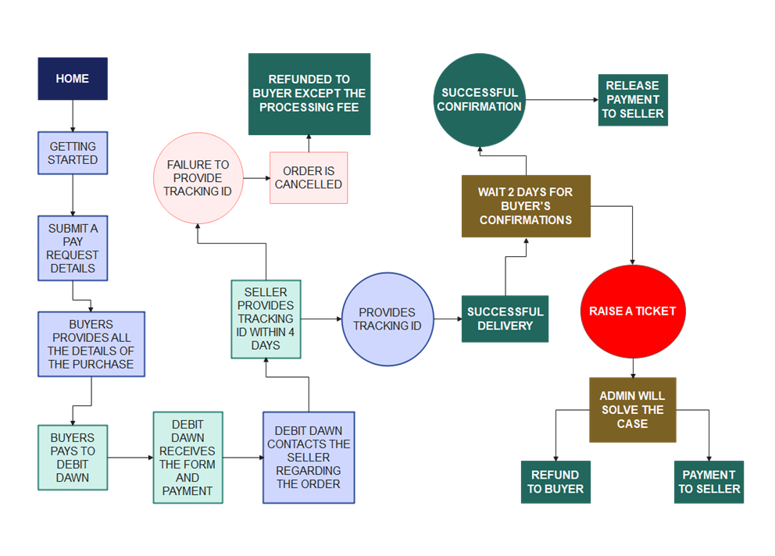

Fig. 1 The FlowState of Debit Dawn

**5. DESIGN AND TEST STEPS / CRITERIA**

1. We installed XAMPP which includes Apache and MyPHP.
2. XAMPP enables us create a local host which can run our website's server.
3. We then install WordPress on our system and link it to XAMPP.
4. We used Colibri Editor to design our website.
5. By default, WordPress comes with many plugins to install and use which indeed can improve the performance of the site.
6. Our website consists of a form which was created using WPForms Free version.
7. To interact with the submissions from the user, we use TableSome which gave us the whole information which was written in the form.
8. An extension called All-in-one Wordpress is used to compile all the designs and data including the plugins to one single file and then it is migrated to Infinity Free App’s web host.
9. If any complaints or disputes raised from either side, the parties are required to submit a mail.
10. An admin will be assigned to the case to solve the complaints or disputes.
11. The mode of conversation can be any medium. But for future reference, we recommend using any method that saves the conversation.

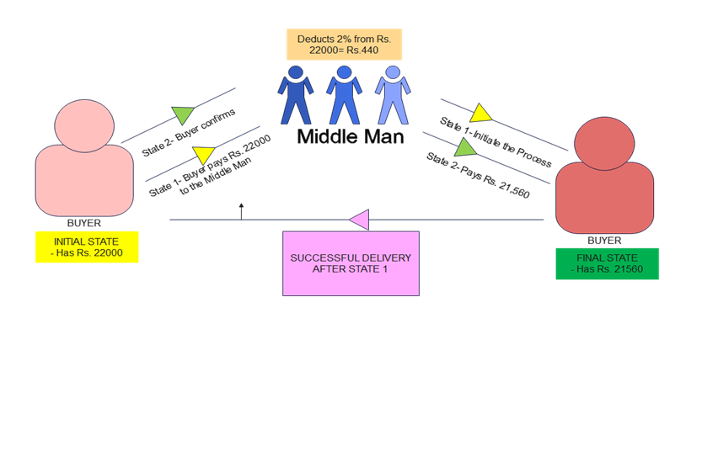

Fig. 2 The State Diagram

**6. ALGORITHM AND SEQUENCE FLOW**

Below is the algorithm used for the sequence flow of Debit Dawn with diagram.

1. Variable A initiate’s communication with variable B to fulfil a demand.
2. Now variable A communicates with variable C to be the middle man for the transaction between A and B.
3. Variable A transfer’s funds to C.
4. Variable C then, initiates communication with variable B to start the process of demand fulfilment.
5. Variable B will then, start and complete the process of demand fulfilment.
6. Variable A shall then check the product or service provided by variable B.
7. Then variable A must confirm to variable C to fulfil the payment to variable B.
8. In case of any complaints raised, either variable (A or B) shall provide appropriate evidence to support the complaint.
9. Variable C shall provide proper solution according to the evidence provided.

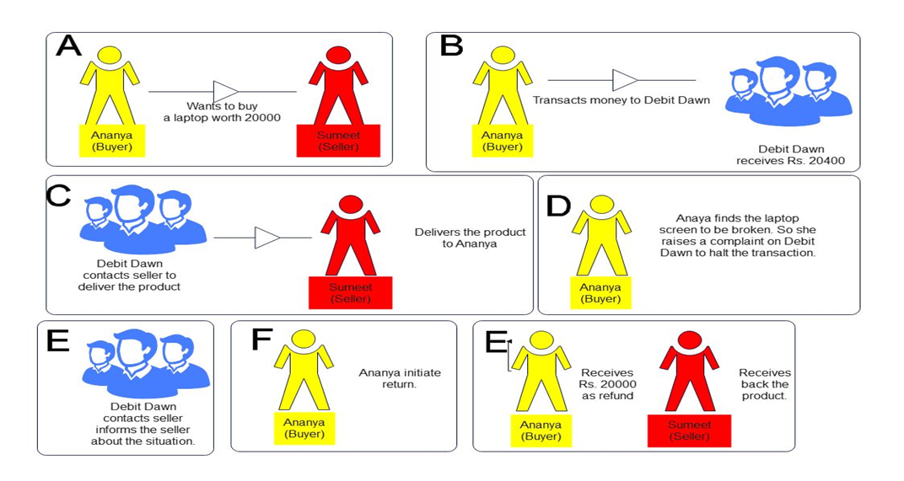

Fig. 3 The Sequence Flow of Algorithm

**7. PLUGINS**

Plugins are the additional extensions or tools which makes the building of a website much easier.

1. **Colibri Page Builder**– It is a type of plugin that enables drag and drop feature on the website.
2. **Humming Bird-** It zips through your site finding new ways to make it load faster, from file compression and minification to browser caching.
3. **Smush-** This plugin helps us to reduce image size, improve performance and boost our Search Engine Optimization using WordPress smush API
4. **Tablesome-** Since, WP forms lite doesn’t provide any functionality to view the entries from the submitted forms, we use tablesome to gather the data directly from WP forms in a tabular manner.
5. **WP forms lite–** It is a dragon drop plugin that is used to create contact forms, query forms which can accept user input.

**8. RESULTS AND OUTPUT**

Below are the results and output of the published website.

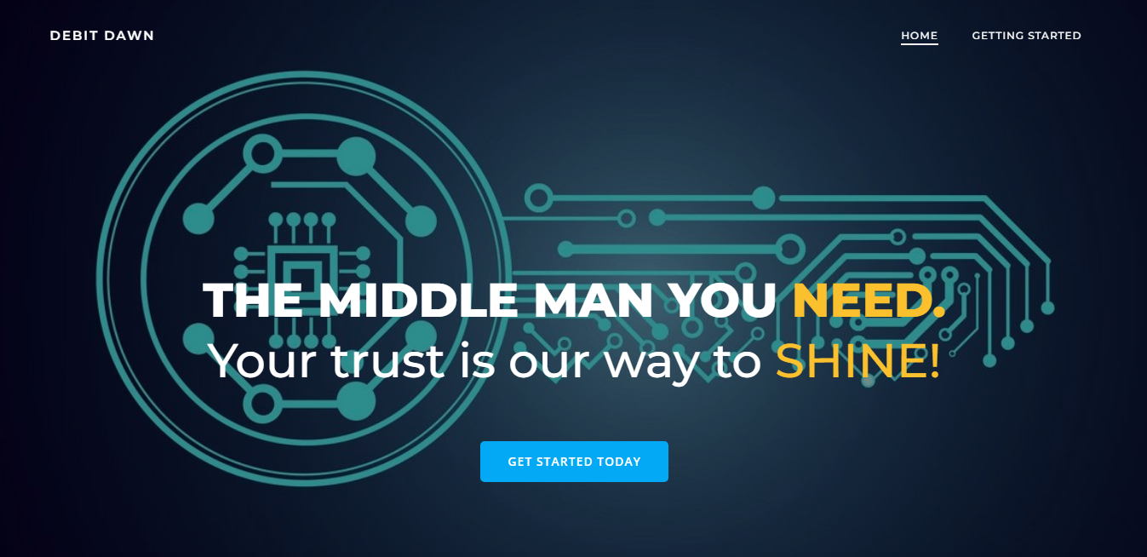

Fig. 4 Getting Started

1. The buyer visit [www.debitdawn.infinityfreeapp.com](http://www.debitdawn.infinityfreeapp.com) and clicks on getting started.

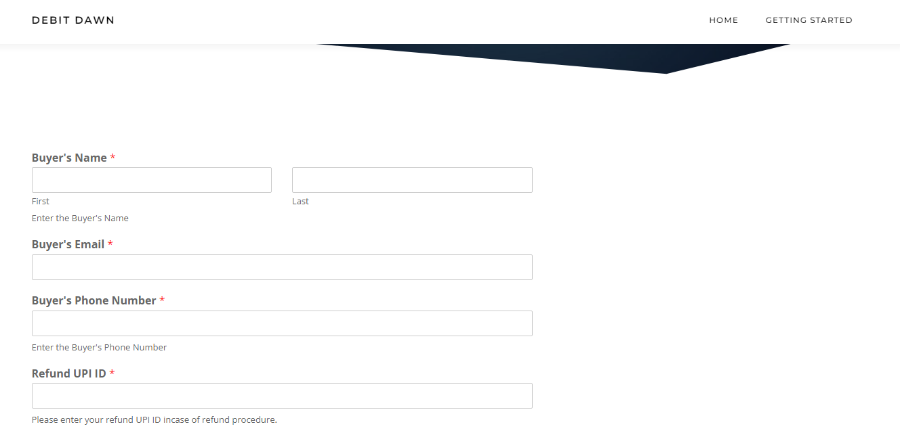

Fig. 5 Redirected to Forms page

2. The buyer is then redirected to a new forms page.

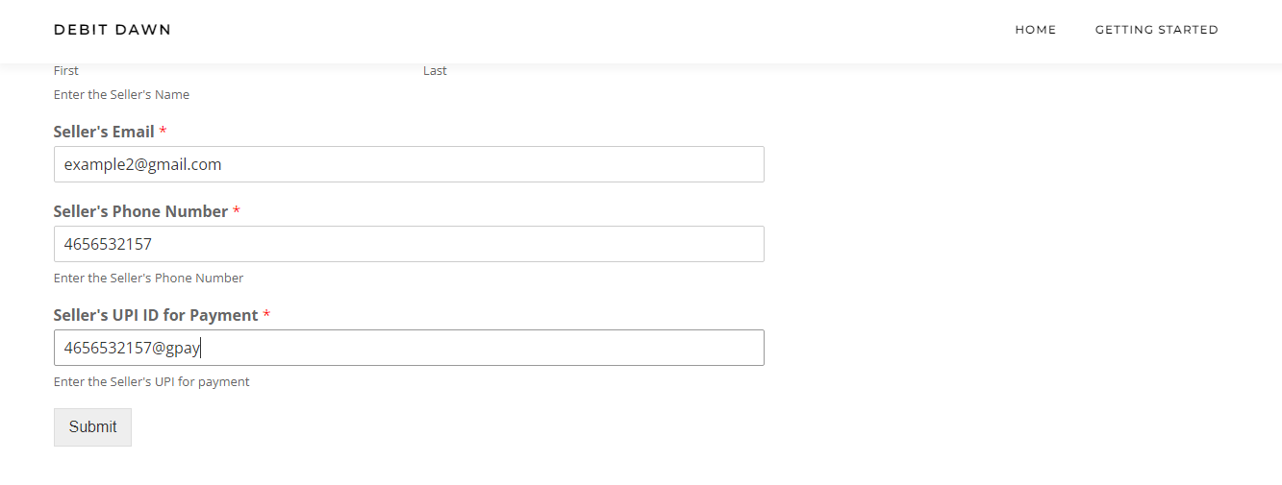

Fig. 6 Filling the Form

3. The buyer fills in the details about thoroughly and submits the form to us.

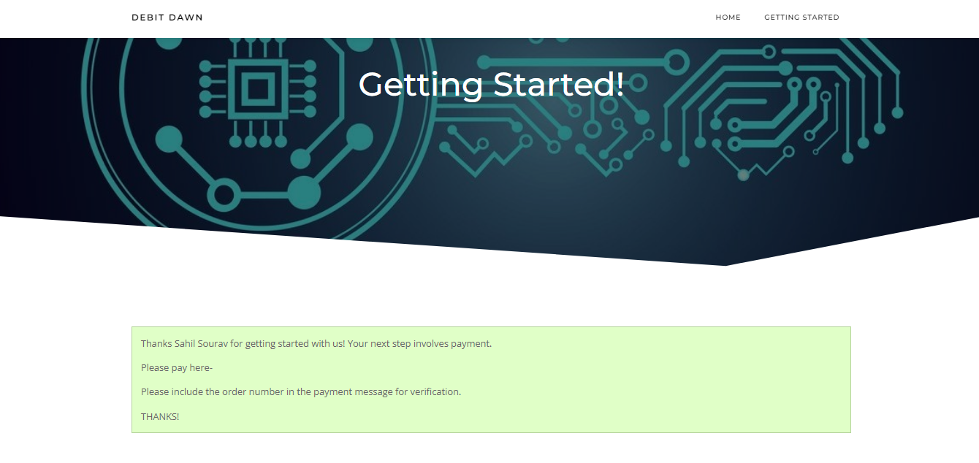

Fig. 7 Submitting the form and Payment

4. The buyer will then submit the form and will be thanked with a confirmation page where the details of the payment will be provided.

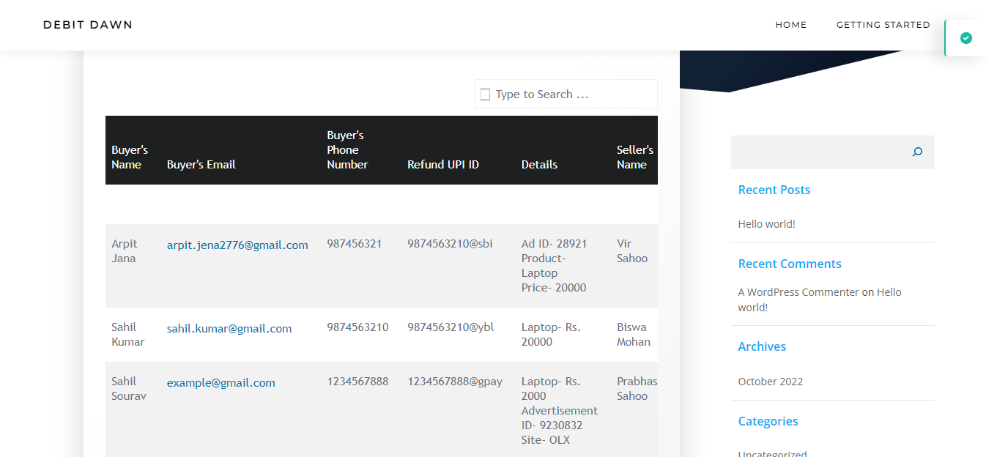

Fig. 8 Submitted Forms in Tablesome

5. All the submitted forms will be displayed in Tablesome plugin in a tabular manner.

6. After this, the admin will contact both the buyer and seller and will initiate the further proceedings.

**9. CONCLUSION**

The purpose of this research was to locate and eradicate the crack in the P2P buying system and create an efficient way for transactions to take place with proper control over cash flow. Based on the analysis convicted, it can be concluded that there are minimal flaws of the Middle Man Theory which can be solved with proper improvements. Our website will not only tackle the problem of distance and trust but will also eradicate it, making it simpler for everyone to purchase what they wanted from the comfort of their home. There are is a vast growth path ahead of Debit Dawn with proper guidance from knowledgeable personalities. Moreover, the website is SSL encrypted, which should give it a head start in the market of start-ups.

**10. REFERENCE**

1. Kalupahana, David J. 1999. Múlamadhyamakakáriká of Nágárjuna: The Philosophy of the Middle Way. Motilal Banarsidass.
2. Middleman By ADAM HAYES
3. What Is the Middleman in Marketing? By Daphne Adams
4. CodewithHarry WordPress tutorial
5. Nesark Tech SSL Certificate
6. WPHowKnow Infinity Free WordPress Tutorial
7. HummingBird by WPMU DEV
8. Colibri Page Builder by ExtendThemes
9. Smush by WPMU DEV
10. Tablesome by Pauple
11. WPForms Lite by WPForms